**Cloudwatch**

* Amazon CloudWatch is a monitoring service for AWS cloud resources and the applications you run on AWS. It is used to collect and track metrics (CPU, Network, Disk and status checks are AWS provided default metrics), collect and monitor log files, and set alarms.
* CloudWatch watches performance

**What can CloudWatch Monitor?**

Amazon CloudWatch can monitor things like:

**Compute**

* EC2 Instances
* Autoscaling Groups
* Elastic load balancer
* Route53 Health Checks

**Storage & Content Delivery**

* EBS Volumes
* Storage Gateways
* CloudFront

**AWS provided metrics (AWS pushes them)**

**Basic Monitoring (default)**: Metrics are collected at a 5 mins interval

**Detailed Monitoring**: Metrics are collected at a 1 minute interval

Includes CPU, Network, Disk and Status Check Metrics

**Custom Metrics (Yours to push):**

**Basic Resolution**: 1 minute resolution

**High Resolution**: all the way to 1 second resolution

Include RAM, application level metrics

Make sure the IAM permissions on the EC2 instance role are correct

RAM is not included in the AWS EC2 metrics

**Host Level metrics consists of**

* CPU
* Network
* Disk
* Status Check

**Monitoring**

With Amazon CloudWatch, the user can get:

* Up-to-minute statistics (Basic and Detailed Monitoring)
* View graphs
* Set alarms for your metric data
* Use Auto Scaling to add/remove resources based on CloudWatch Metrics

**CloudWatch Monitoring:**

* **Basic Monitoring for Amazon EC2 instances:**  Ten pre-selected metrics at five minute frequency, free of charge
* **Detailed Monitoring for Amazon EC2 instances:** Seven pre-selected metrics at one minute frequency, for an additional charge
* **Amazon EBS volumes:** Ten pre-selected metrics at five-minute frequency, free of charge
* **Elastic Load Balancers:** Ten pre-selected metrics at one-minute frequency, free of charge
* **Auto Scaling groups:** Seven pre-selected metrics at one-minute frequency, optional and charged at standard pricing
* **Amazon RDS DB instances:** Thirteen pre-selected metrics at one-minute frequency, free of charge.

**CloudWatch Provides metrics for every services in AWS**

* **Metrics:** Metrics is a variable to monitor (CPU Utilization, Networkin, etc.)
* **Alarms**: An Alarm basically watches over a particular metric for a stipulated period of time and performs some actions based on its trigger. These actions can be anything from sending a notification to the user using SNS.
* **Namespaces:** A container for CloudWatch metrics**.** It is a grouping to know what this metric belongs to. For example: AWS/EC2, AWS/Auto Scaling/ AWS/ELB
* **Dimensions:**  Dimension is a name/value pair that you uniquely identify a metric.
* For example: AutoScaling GroupName, Imaged, Instance ID, Instance Type, and Volume ID.
* **Timestamps:** To know what timestamp it had captured.
* **Units:** Unit represents the statistic’s unit of measure. For example: EC2 NetworkIn metric in bytes.

Cloud watch is all about:

* Alarms
* Events
* Logs
* **Cloudwatch Alarm States**
  + State is Alarm
  + State is OK
  + State is INSUFFICIENT

**Metrics Retention Period**

CloudWatch Metrics now supports the following three retention schedules:

* 1 minute data points are available for 15 days
* 5 minute data points are available for 63 days
* 1 hour data points are available for 455 days
* **CloudWatch Events**

Amazon CloudWatch Events delivers a near real-time stream of system events that describe changes in Amazon Web Services (AWS) resources.

Cloud watch Events are stored in **Cloudwatch Event Bridge**

* Determine events of interest
* Create rules to match events
* Route to targets

**CloudWatch LOGS**

You can analyze your logs with CloudWatch Logs Insights. No Infrastructure or setup needed.

CloudWatch Logs helps you to aggregate, monitor, and store logs. For example, you can:

* Monitor HTTP response codes in Apache logs
* Receive alarms for errors in kernel logs
* Count exceptions in application logs

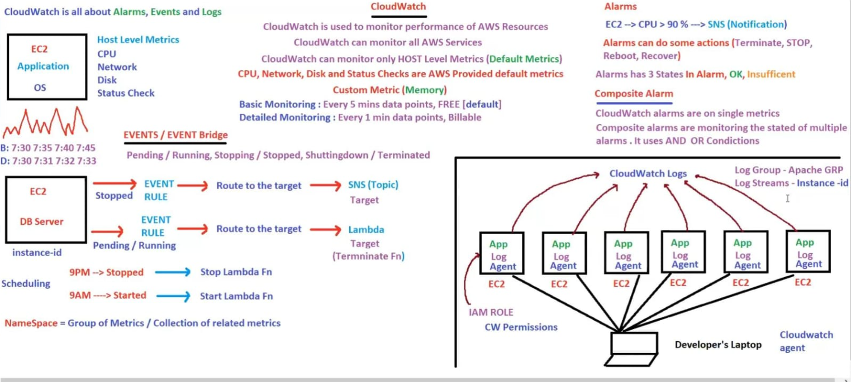

**AWS lambda**

* AWS Lambda is an Amazon server less computing system that runs code
* Lambda is used for Automation, we will create lambda function
* Lambda is invoked based on the trigger/event
* It is an event-driven compute service.
* 1 million requests free per month
* Up to 3.2 million seconds of compute time per month is free
* Lambda free tier
* Disk capacity in the “function container” in/tmp=512MB-10GB

**Benefits**

* No maintenance-AWS will take care
* Pay as per usage
* High availability- no downtime
* Scalability
* Monitoring
* Logging –how code is working

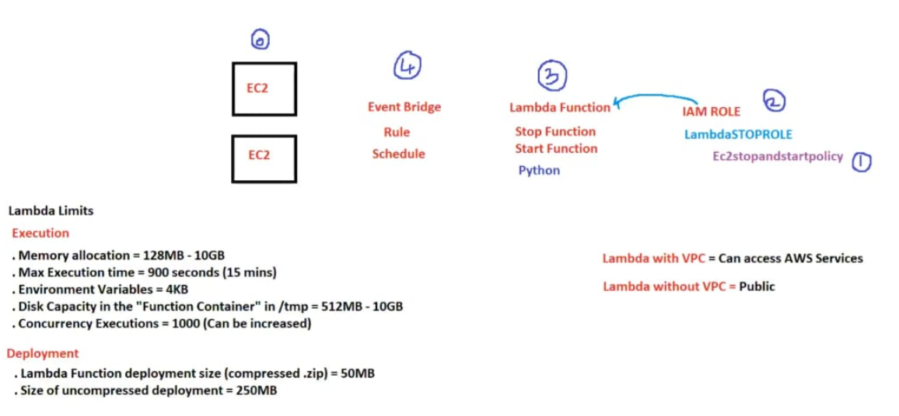

**Example:**

Lambda function to stop and start Amazon EC2 instances at regular intervals

For polices creating-inline policies function code

{ "Version": "2012-10-17",

"Statement": [

{

"Effect": "Allow",

"Action": [

"logs:CreateLogGroup",

"logs:CreateLogStream",

"logs:PutLogEvents"

],

"Resource": "arn:aws:logs:*:*:*"

},

{

"Effect": "Allow",

"Action": [

"ec2:Start*",

"ec2:Stop*"

],

"Resource": "*"

}

]

}

To stop the EC2 python code;

import boto3

region = 'ap-south-1'

instances = ['i-0e7025a9168cafc13’,‘i-04fbf270a3fd9bdcc’]

ec2 = boto3.client('ec2', region_name=’ap-south-1’)

def lambda_handler(event, context):

ec2.stop_instances(InstanceIds=instances)

print('stopped your instances: ' + str(instances))

**What is Cloud Trail**

AWS CloudTrail increases visibility into your user and resources activity by recording AWS Management Console actions and API calls.

You can identify which users and accounts called AWS, the sources IP address from which the calls were made, and when the calls occurred.

**CloudWatch vs CloudTrail**

AWS CloudWatch monitor performance (cloudwatch can monitor lambda functions, Micro services, containers, K8s etc.)

AWS CloudTrail monitors API calls in the AWS Platform